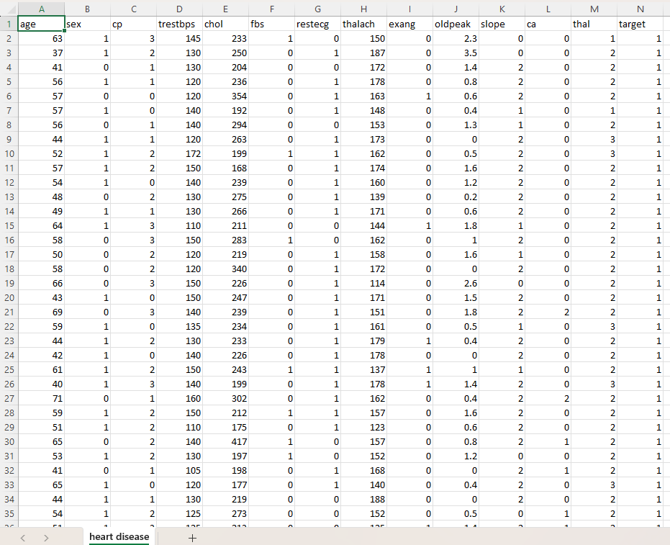

Name of Feature Description Type Relevance w.r.t other Features
1.Age Age of the patient Quantitative, Continuous Relevant, Health insurance benefits are depending upon patient’s age
2.sex Gender Quantitative, Binary Relevant, sex defines gender identification as Male or female i.e. Male or Female
3.cp Chest Pain Quantitative, Discrete Relevant, it includes different types such as
0 = typical angina, 1 = atypical angina, 2 = non-anginal pain, 3 = asymptomatic.
4.trestbp Resting blood pressure Quantitative, Continuous partially Relevant, it is taken at the time of hospital admission, measured in (mm/Hg)
5.chol cholesterol level Quantitative, Discrete Relevant, serum cholesterol level measured
in (mg/dl)
6.fbs fasting blood sugar Quantitative, Binary Relevant, if fasting blood sugar>120mg/dl?
(1=yes,0=No)
7.restecg Resting Electro cardio Quantitative, Binary Relevant, 0 = normal, 1 = ST-T wave graphic results abnormality, 2 = left ventricular hypertrophy.
8.thalach Heart Rate Quantitative, Discrete Relevant, Maximum heart rate achieved during exercise
9.exang Exercise induced angina Quantitative, Binary Relevant, Chest pain during exercise
10.oldpeak Measure of heart stress Quantitative, Continuous Relevant, ST depression induced by exercise relative to rest
11.slope Slope of the peak exercise Qualitative, Ordinal partially relevant, it represents ST segment
0= uplsloping,1 =flat, 2=down sloping
12.thal Thalassemia Qualitative, Nominal Relevant, Blood disorder type1 = normal,
2 = fixed defect, 3 = reversible defect
13.target Diagnosis of Heart Disease Qualitative, Nominal Relevant, Diagnosis of heart disease: 1 =
presence, 0 = absence

